**Python-Django Internship Report**

**Personal Details**

Name : Vishrut Riteshkumar Mehta

College Name : LJ Institute of Engineering and Technology

Degree : BE-Computer Engineering

Semester : 7

Github URL : <https://github.com/VishrutMehtaVince>

**Company Details**

Company Name : Akash Technolabs

External Guide : Akash Padhiyar

Training Duration : 25-05-2021 to 07-06-2021

**Index**

|  |  |  |
| --- | --- | --- |
| **Index** | **Task Detail** | **Page Name** |
| 1 | HTML Code for registration form | 1 |
| 2 | Fetch Data From Database | 2 |
|  |  |  |
|  |  |  |
|  |  |  |

1- Python Introduction & HTML Code for registration form

On day-1 we were taught basics of python and were told to create a registration form using html.

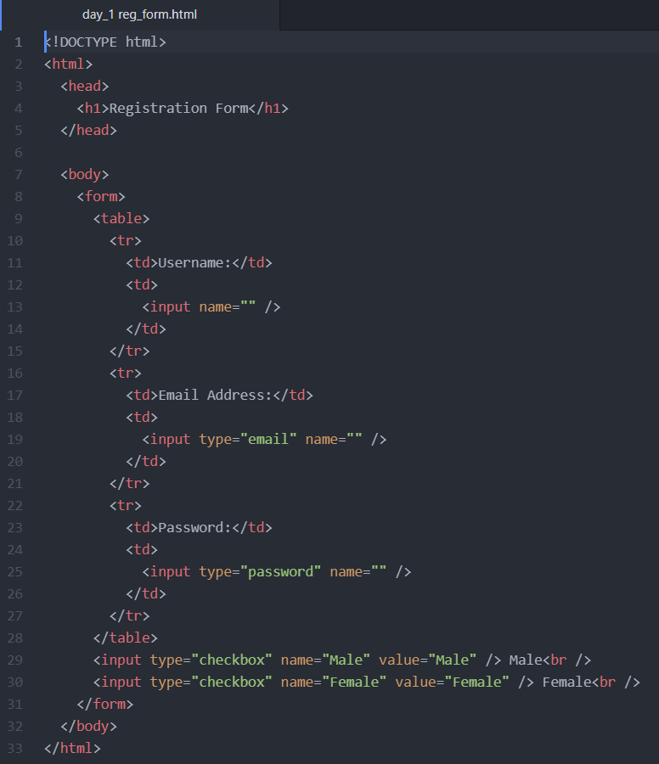

Output

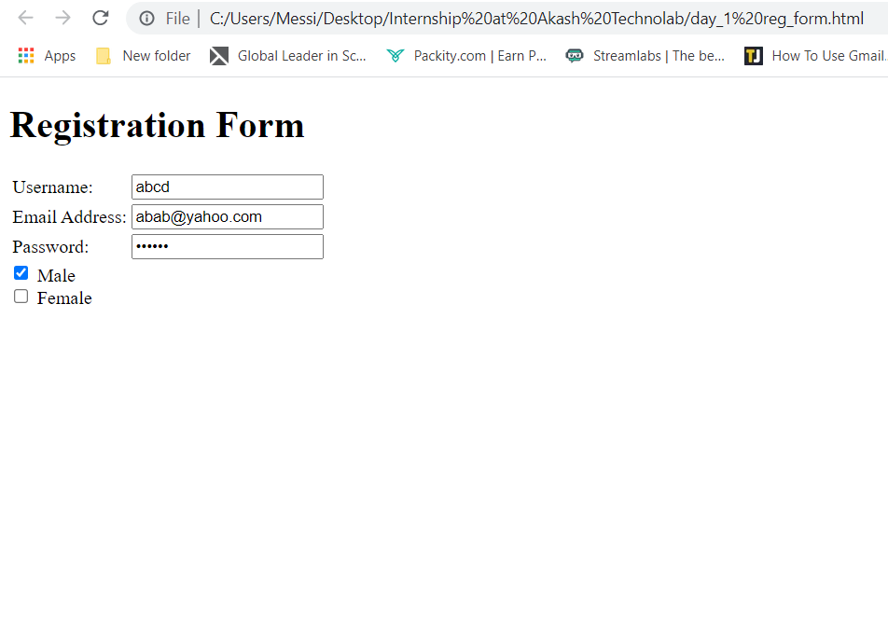

2- Variables and Datatypes in Python

On day-2 we were taught different variables and datatypes in python and were told to perform following tasks.

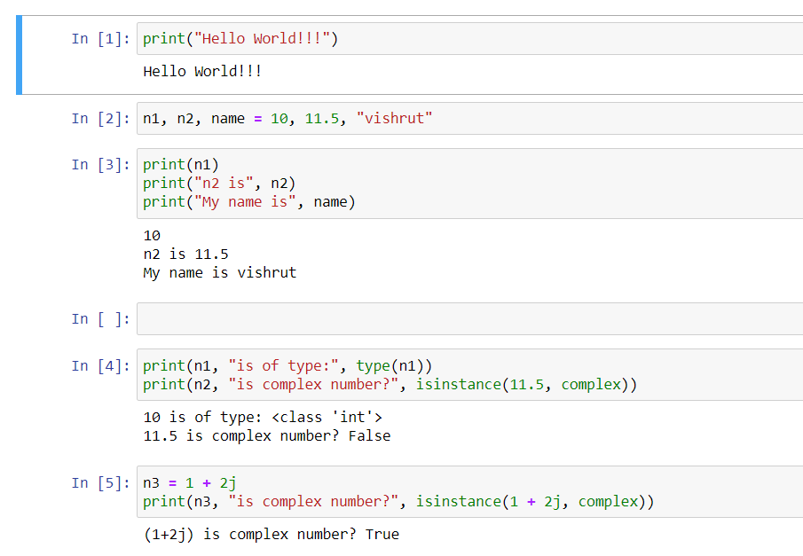

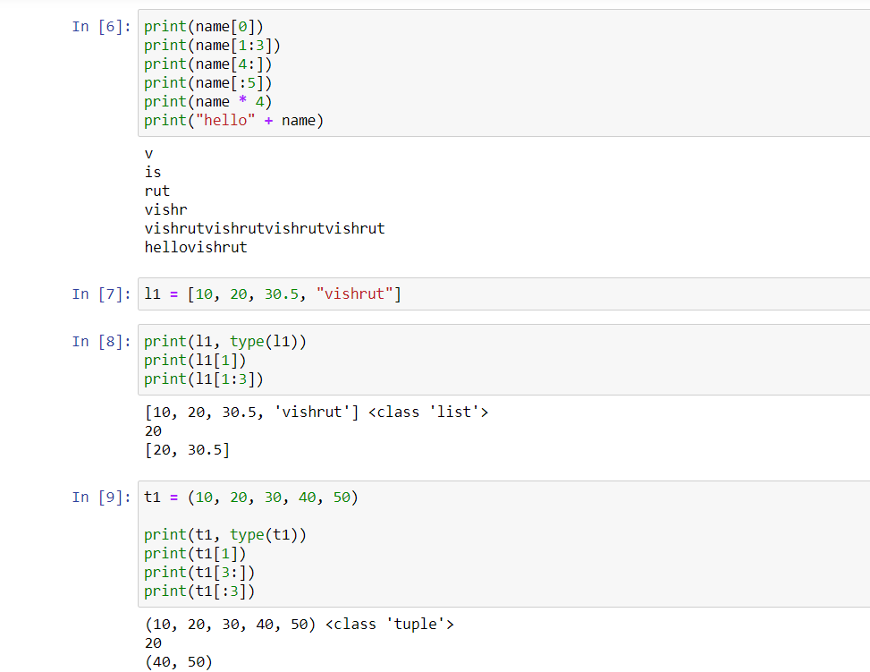

3- Python Conditional Statements, Loops, Break, Continue

On day-3 we were taught how and when to use conditional statements and loops in python.

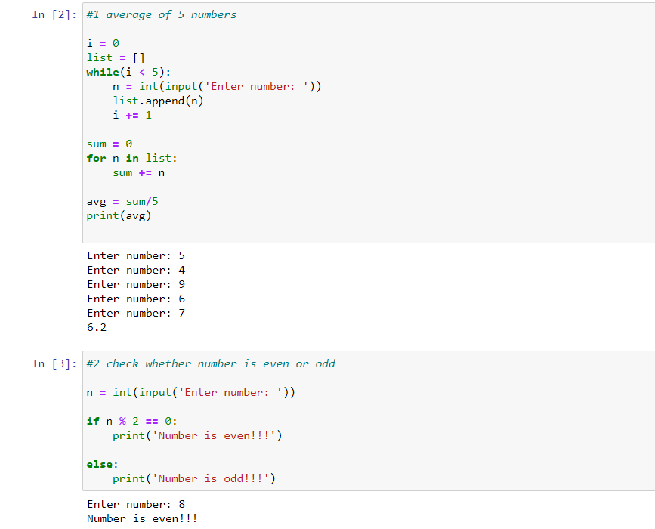

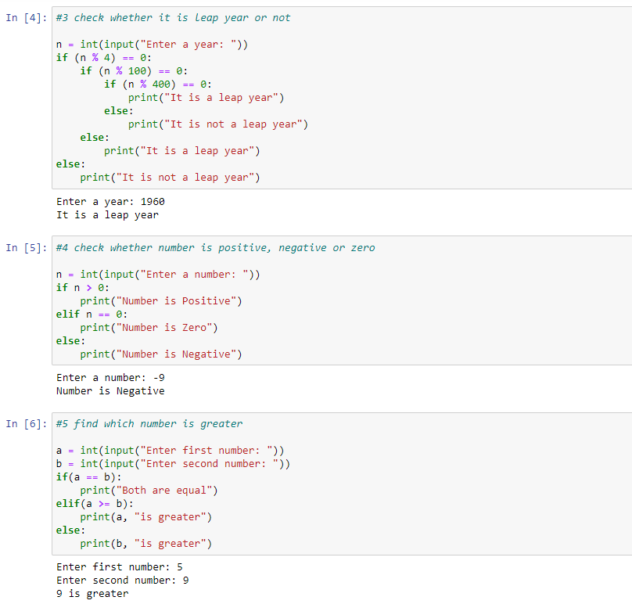

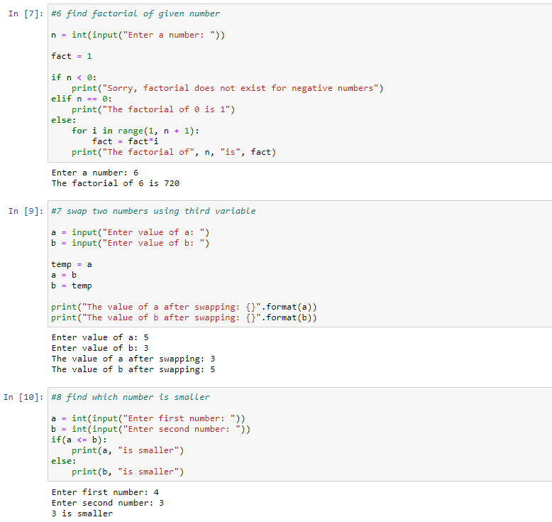

4- Functions and Operators in Python

On day-4 we were taught about functions and different types of operators in python.

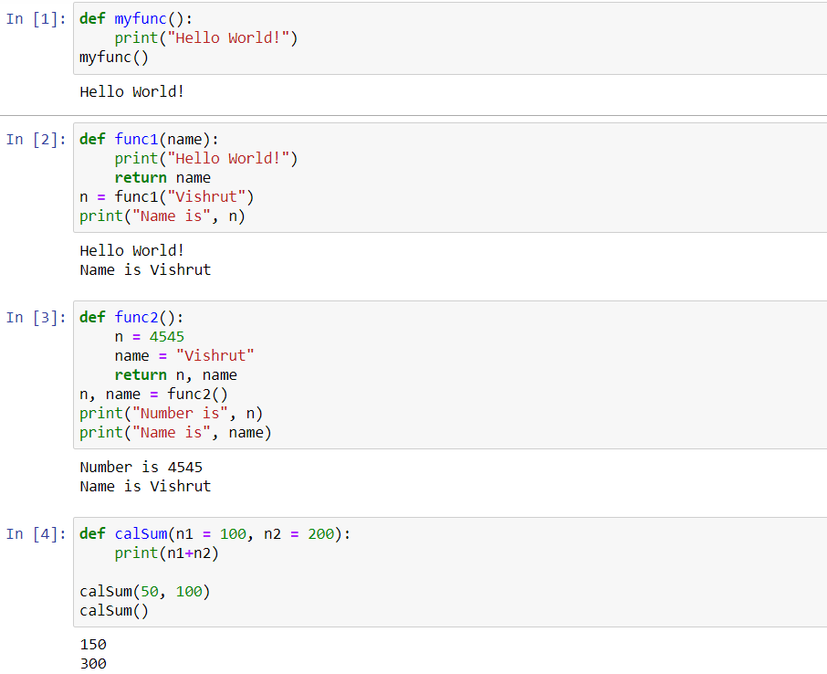

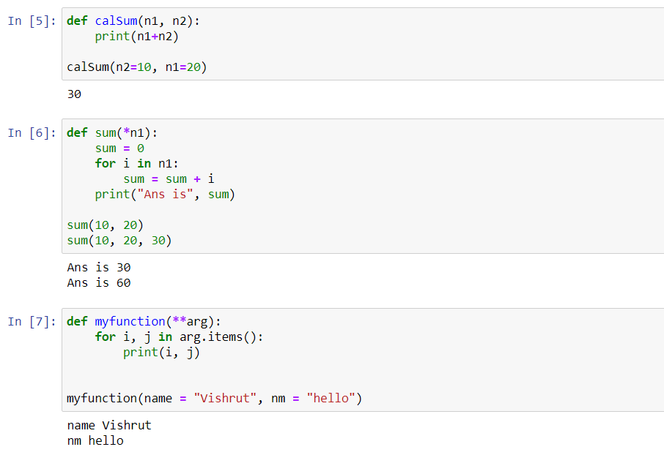

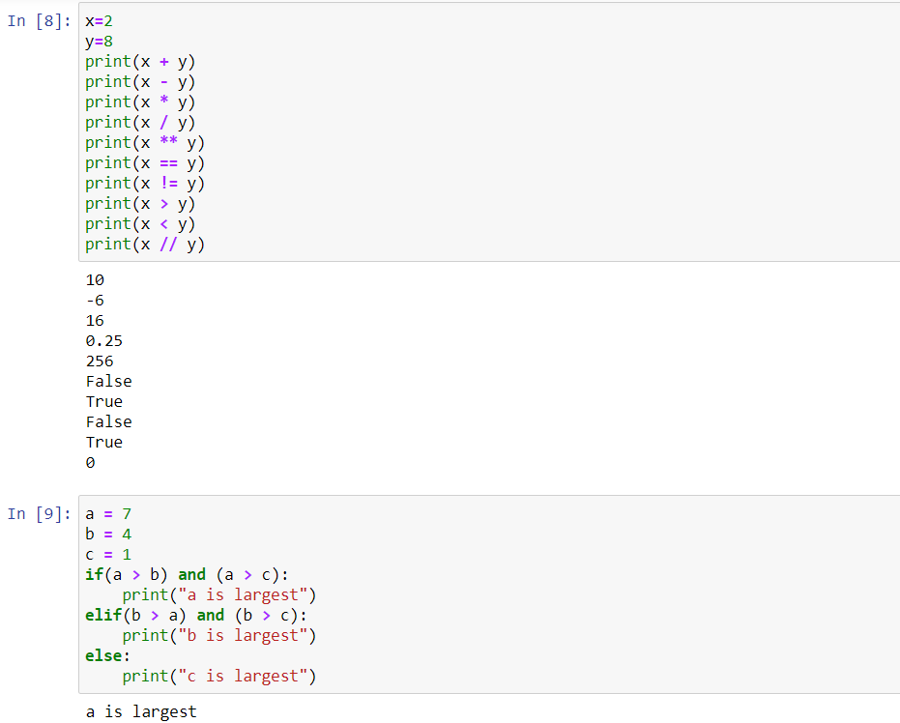

5- Object Oriented Programming in Python

On day 5 we were introduced to object-oriented programming in python and were taught about classes, objects, and methods in python.

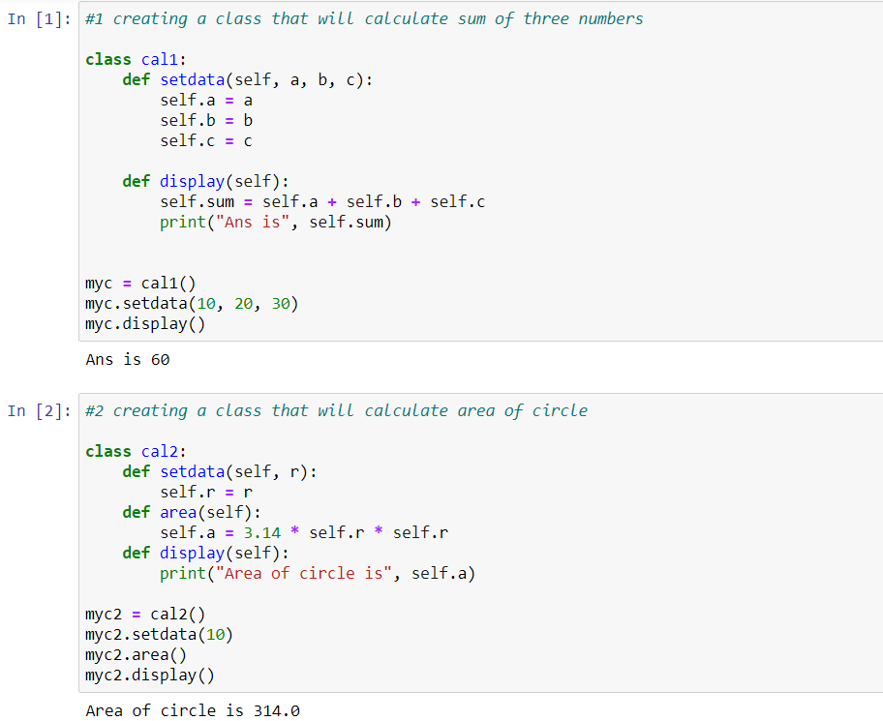

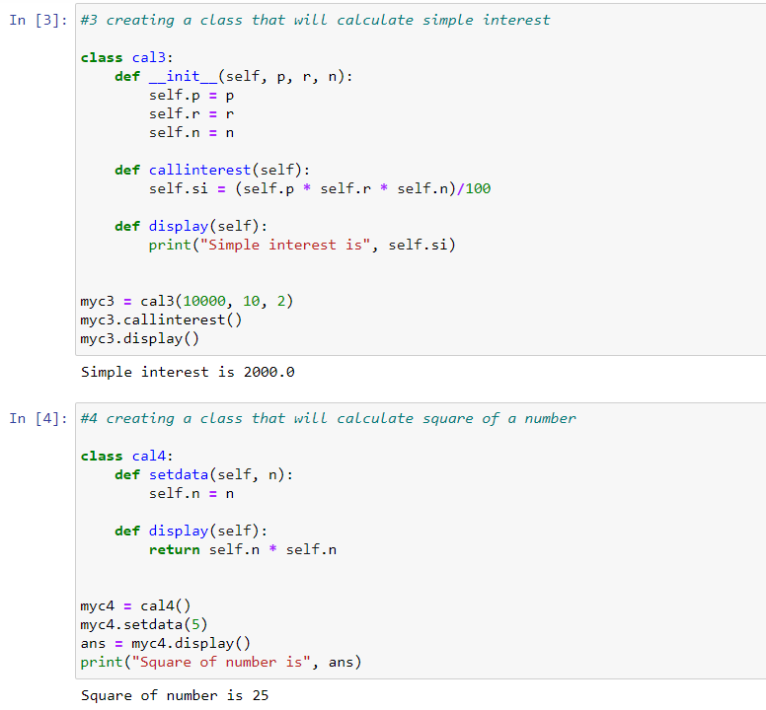

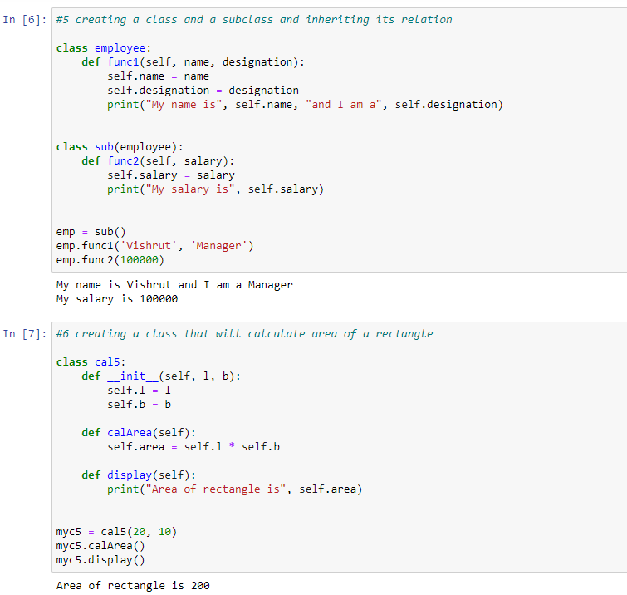

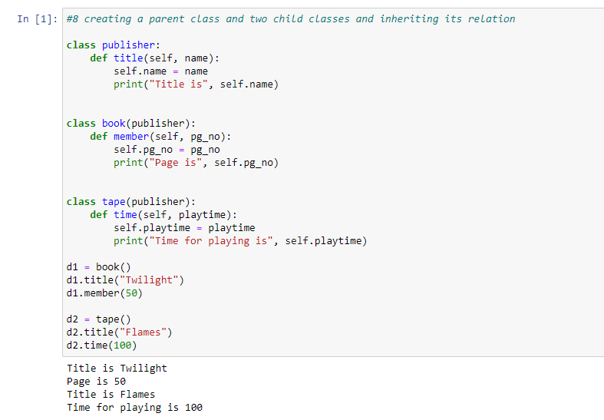

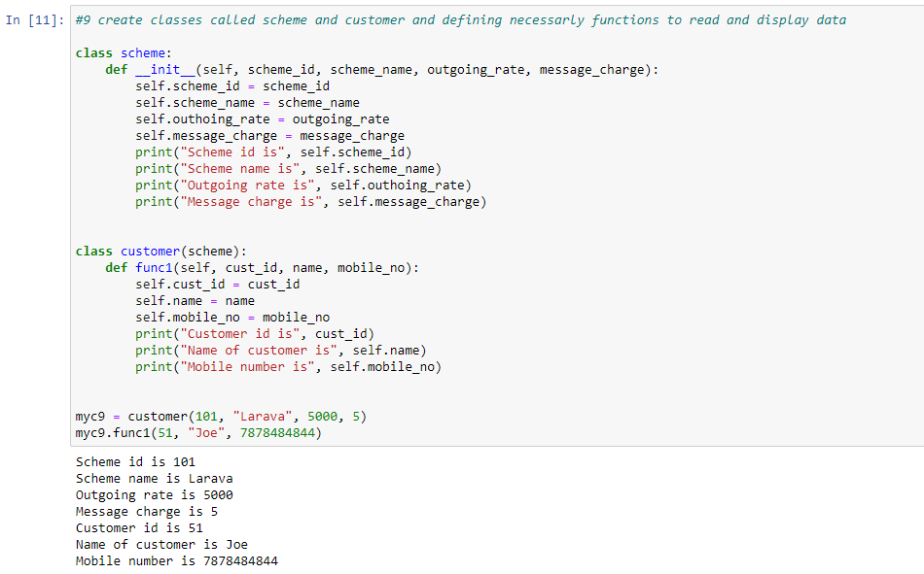

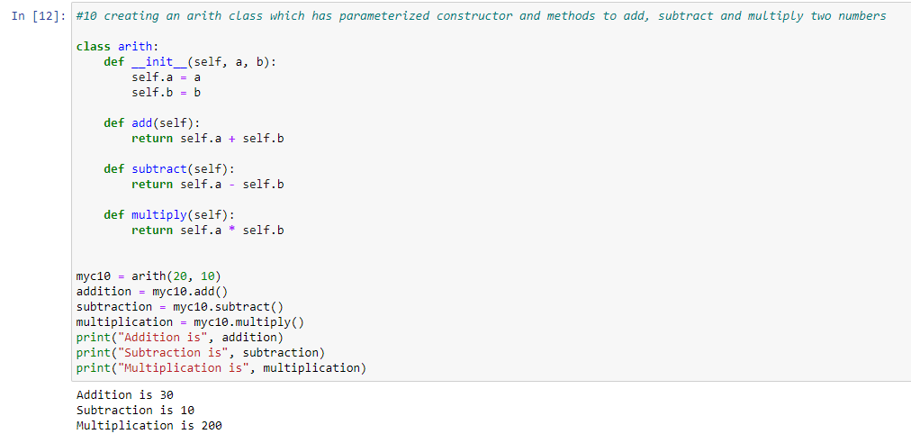

6- Django Framework in Python

From day-6 until day-14, we were taught about Django framework and we were given a project to perform which is as follows.

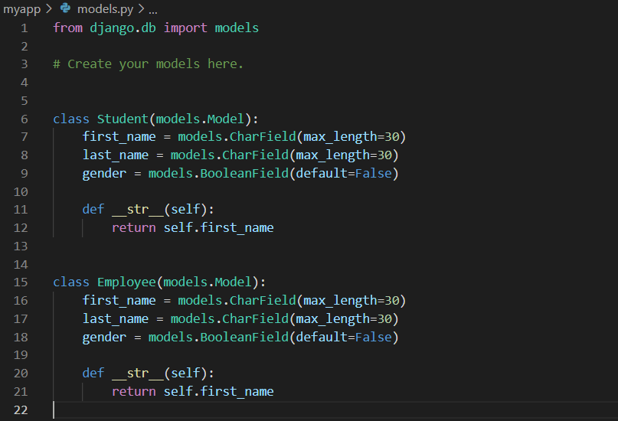

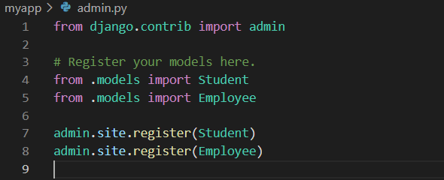

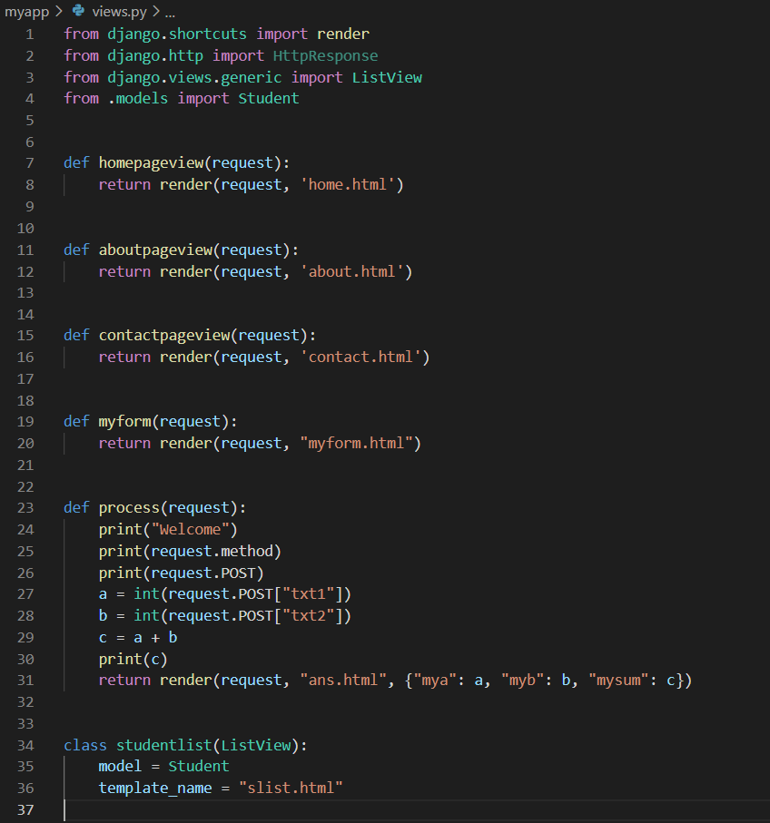

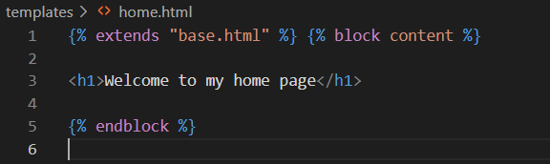

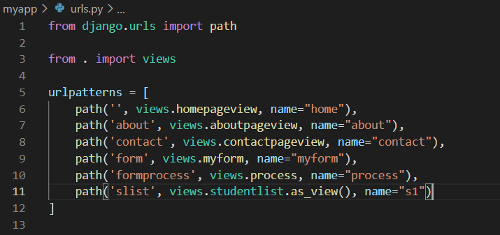

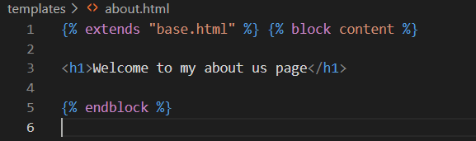

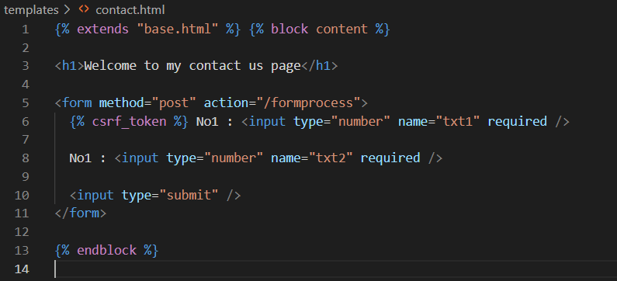

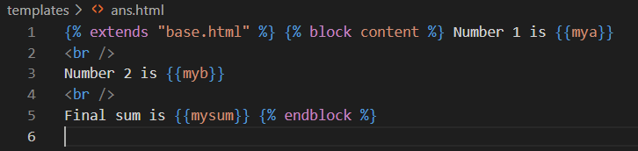

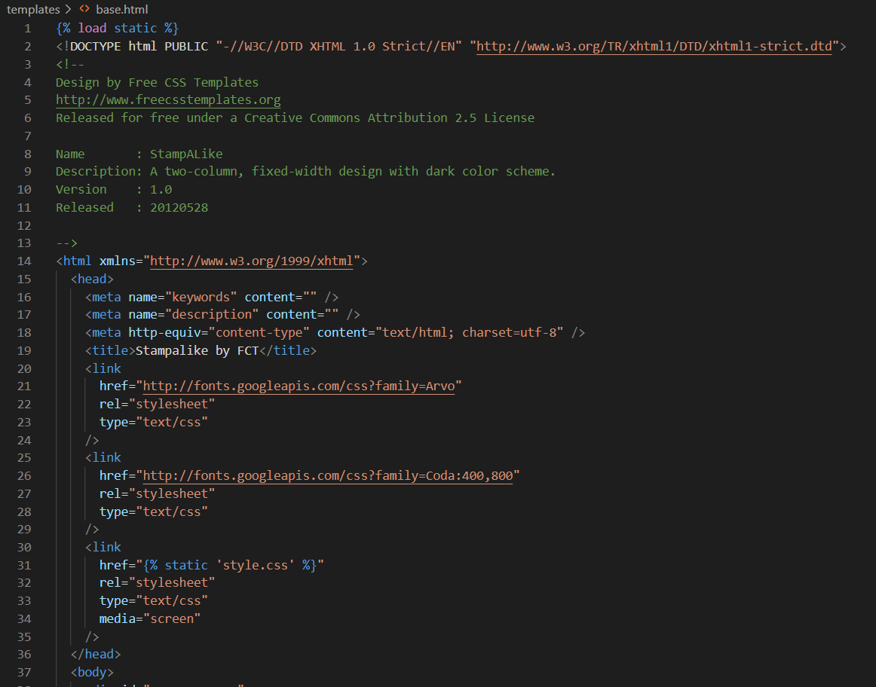

Output-

